Phase 2: Org Setup & Configuration Salesforce Editions
• The Student/Developer Edition is used to build the Community Health & Donation Tracking system. It offers core CRM features like custom objects for Patients, Donations, and Campaigns, plus automation via Flows. Though limited compared to Enterprise, it allows sufficient customization, reports, and dashboards to demonstrate nonprofit healthcare impact.

Company Profile Setup
• The company profile defines organization settings for the nonprofit healthcare initiative. It stores details like organization name, primary contact, default time zone, and currency for donation tracking. Configuring this ensures all patient records, donation amounts, and campaign activities align with consistent organizational metadata and reporting standards across the project.

Business Hours & Holidays
• Business hours define when healthcare workers and volunteers are active. Holidays identify days when campaigns or donation services pause. For example, clinic working hours can be set for reporting response times. Configuring this helps align donor service, patient care follow-ups, and automated communication with actual operational availability.
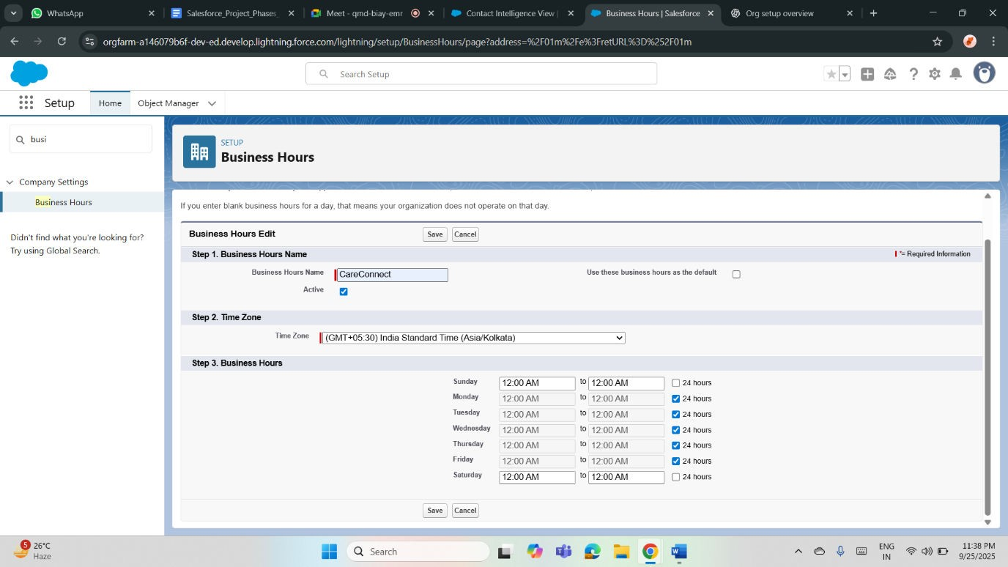

Fiscal Year Settings
• Fiscal year settings standardize how donations and patient program outcomes are tracked financially. A custom fiscal year can be defined if nonprofit funding cycles differ from the calendar year. Aligning fiscal periods helps report total donations, resource allocation, and healthcare program performance in meaningful time-bound comparisons for stakeholders.
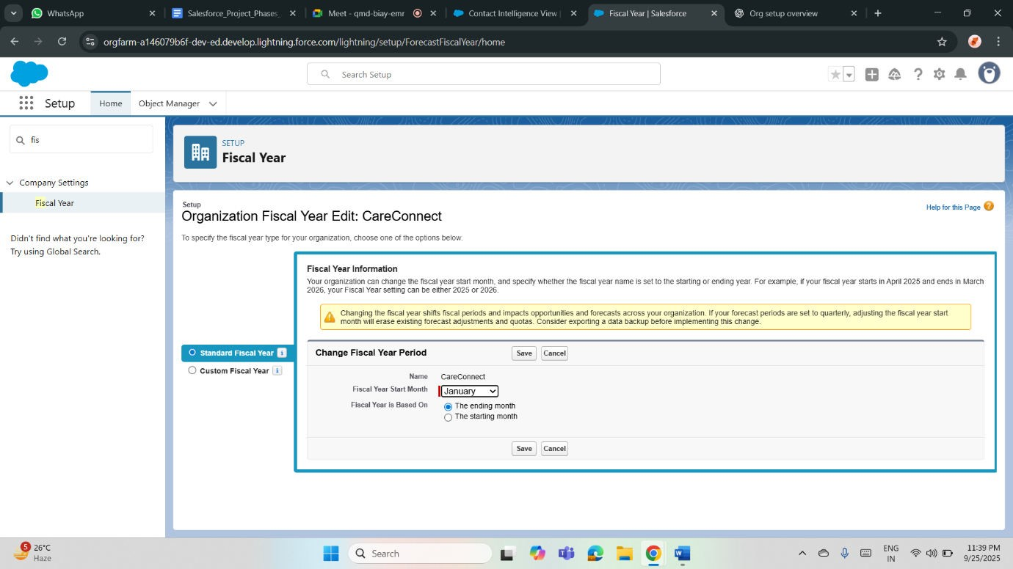

Profiles
• Profiles control what each user can do within the system. For example, healthcare staff may edit Patient records but only view Donations. Donor-facing profiles might access dashboards without editing rights. Custom profiles ensure sensitive health and donation data is protected while allowing efficient management of records relevant to each role.
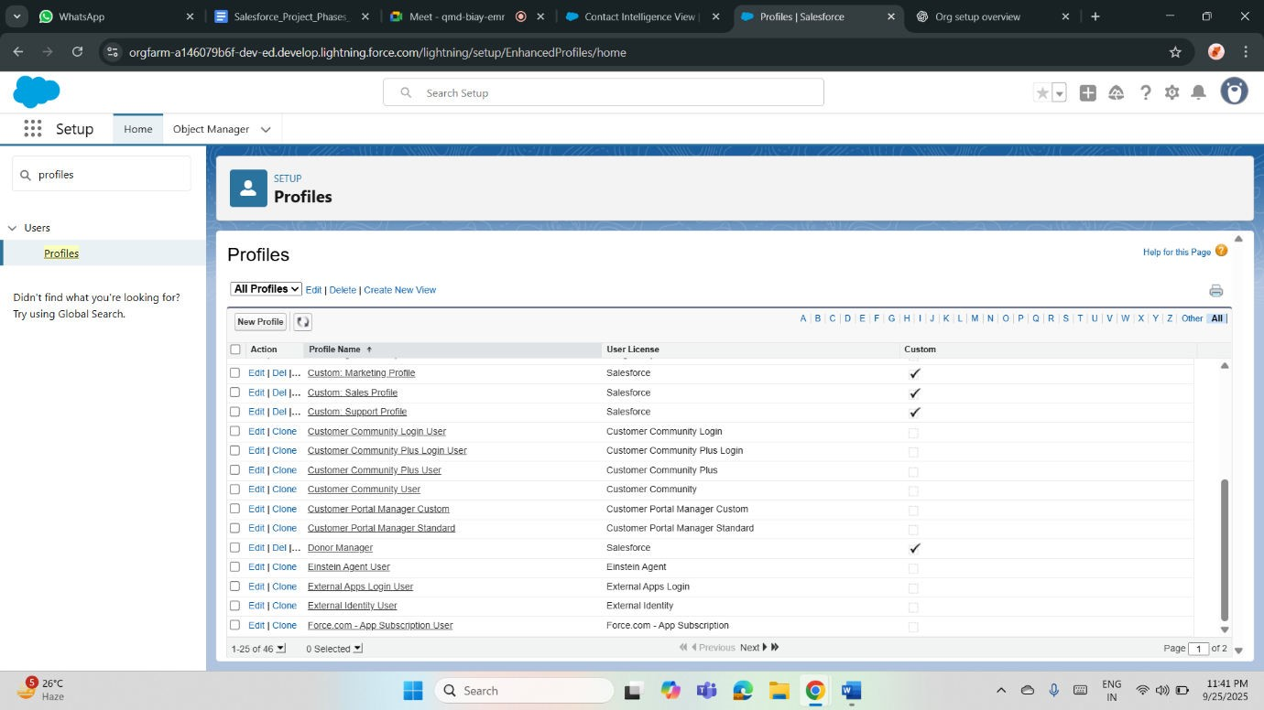

Roles
• Roles define data visibility in the health and donation system. A hierarchical structure allows managers to view all data while staff only access their records. Example: Program Manager sees all patient treatments and donations; volunteers see only patients they served. Roles ensure controlled data visibility with accountability.
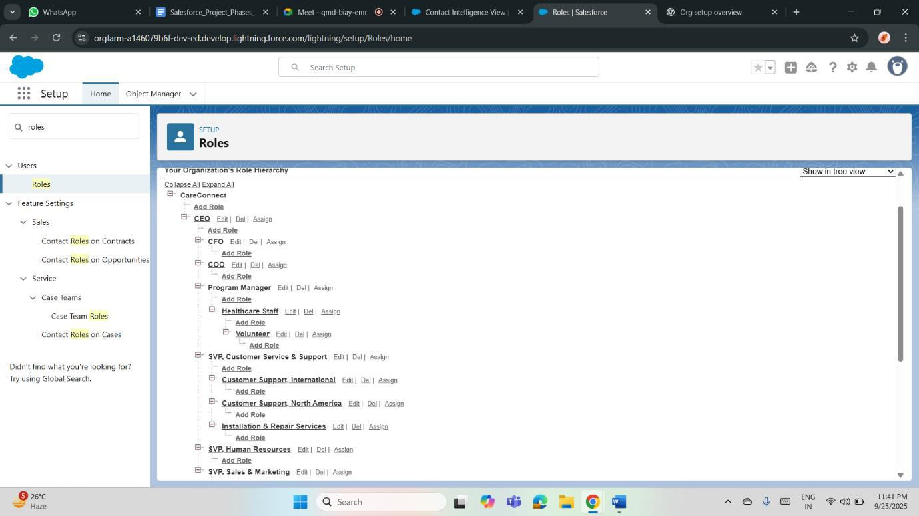

Permission Sets
• Permission sets provide additional access without changing profiles. For example, a healthcare volunteer may need temporary access to enter donation records or view campaign dashboards. Assigning permission sets helps extend privileges flexibly, ensuring project scalability. They also allow selective testing of advanced features without overpermitting basic staff profiles.
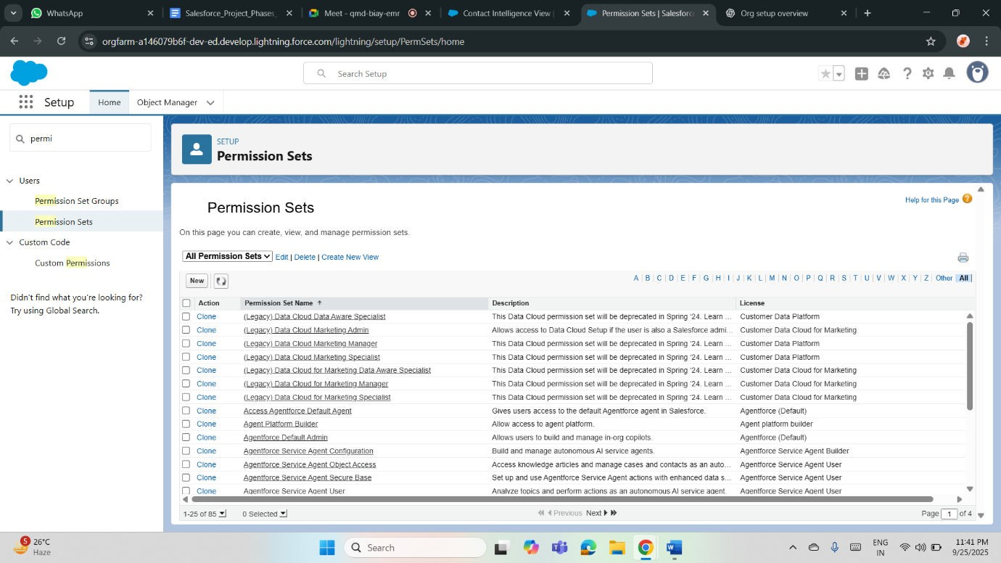

OWD (Organization-Wide Defaults)
• OWD defines baseline record access. Patient__c and Donation__c objects can be set as Private to protect sensitive data. Campaigns may be Public Read-Only for broader access. This ensures donor, patient, and program data are secure by default, with visibility extended only through roles and sharing rules where appropriate.

Sharing Rules
• Sharing rules grant broader access beyond OWD. Example: a donor manager role can be given Read-Only access to Donation__c, while healthcare managers can see linked Patient records. Campaign coordinators may share visibility for program outcomes. Sharing rules balance confidentiality with collaboration by extending controlled data visibility across teams.
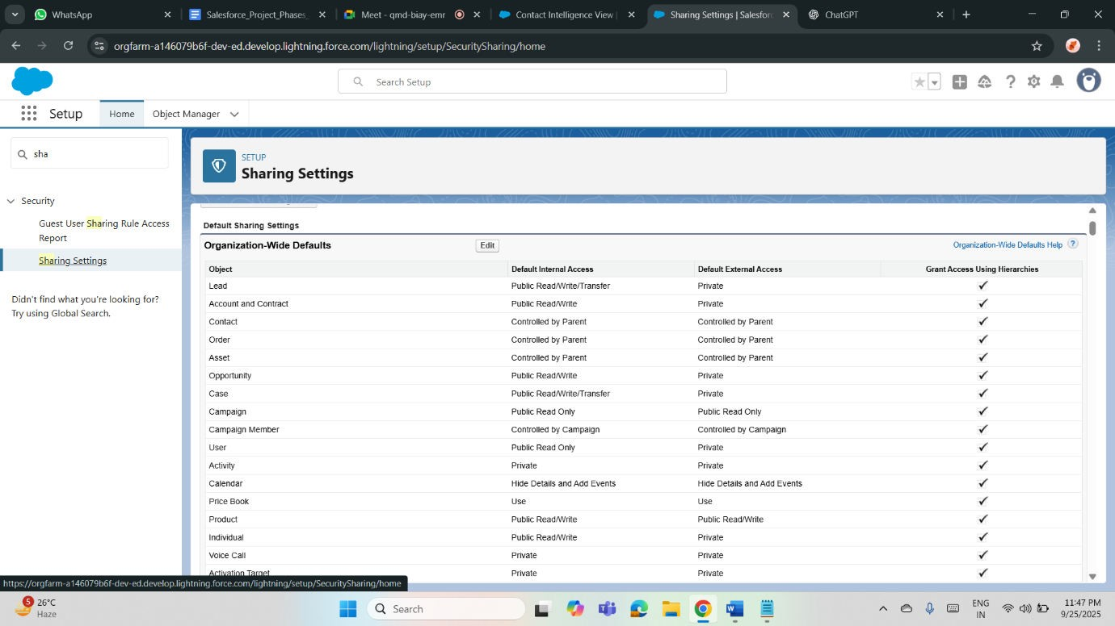

Login Access Policies
• Login access policies define how users and admins securely access the system. Admins can temporarily log in as staff for troubleshooting patient or donation record issues. Configuring secure expiration periods for delegated access maintains data privacy. This ensures compliance, transparency, and smooth support for healthcare program operations.

Dev Org Setup
• A Salesforce Developer Org is used to design, test, and validate the Community Health & Donation Tracking system. It includes standard and custom objects, automation via Flows, and dashboards. This environment enables experimentation and configuration of core features before moving into production or presenting the final capstone solution.

Deployment Basics
• Deployment involves moving configuration from sandbox or developer org to the main environment. For the student project, deployment basics focus on change sets or metadata migration

